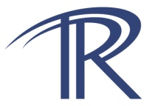  National Organization of Test, Research, and Training Reactors | 2019 Test, Research and Training Reactors  Facts and Information

Test, Research and Training Reactors fulfill a wide range of peaceful use applications in science, engineering and technology. The role research reactors play today is critical as the country pursues environmentally safe, effective methods to generate the power necessary to keep the United States at the cutting edge of technological development. Not only is the education of the future nuclear workforce critical to our energy infrastructure, we must also provide the means to evaluate new science and engineering developments such as superconductors and nanotechnology. These research reactors have been the workhorses of the education and research infrastructure, and with continued support can remain so well into the future.

Research Reactors have provided critical tools that have advanced the development of reliable satellite communications technology, superconductor technology used in supercomputers, advanced materials research and both nuclear and alternative energy development.

Continued support by the Department of Energy and Congress is vital to maintaining these valuable assets, through technology upgrades of reactor instrumentation via programs such as the DOE University Programs-Reactor Upgrades, and the DOE University Programs-General Scientific Infrastructure grants. The research reactor community hopes that these programs can continue in order continue to provide the nation with important tools for the education of a well-informed workforce and public.
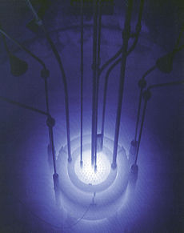  The Reed College Research Reactor, Portland, OR | “The use of our university and public institution research reactors in their research mission, and in educating our public about Nuclear Science and Technology, is vitally important and it is also a Federal responsibility. It provides to some of our citizens the wisdom and freedom for overcoming irrational fear, and to others it grants the inspiration and the spark to innovate, to design and to build. Nuclear education is rightly a federal issue; it expands US leadership in this critical sector and an educated and inspired populace will contribute both to National Security and our Nation’s Energy Security.”  C. L. Munns, Vadm/USN (ret)., Former CEO of Flour LLC
Background Research Reactor Facts
- There are currently 41 research reactors operating in the United States, 9 that are licensed by the DOE/DOD, and 31 that are regulated by the U.S. Nuclear Regulatory Commission (USNRC), twenty-seven at universities or colleges.
- The reactors perform a wide range of research missions, including: studies of neutron physics properties, neutron scattering experiments which provide information about materials used in physical science, engineering and bio-science applications, including nano-technology; neutron radiography studies, which provide ways to determine structural integrity for aerospace, automotive and other engineering uses; neutron activation analysis which provides a very powerful method of non-destructive measurement of trace elements, which has wide uses in environmental studies, archaeology, criminology, among others.
- University research reactors are critical in the education of the nuclear workforce, providing a hands-on tool for instructing the nuclear engineers and technicians of tomorrow the properties of reactor physics and technology in a very safe and controlled environment.
- Research reactors perform the vital role of educating the public about the science of nuclear technology, and demonstrate the safe and effective use of nuclear reactors, which play an important role in the generation of electricity for the nation presently, and will be able to fulfill the new demands of electric vehicles and hydrogen generation for fuel cells for the vehicles of tomorrow.

